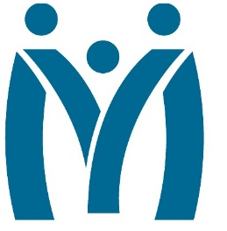

Metropolitan Human Services District
Board of Directors Meeting
Wednesday, February 22, 2023| 9 AM

3100 General DeGaulle Drive, New Orleans, LA 70114

MHSD fulfills its statutory role as the planning body for the behavioral health, addiction, and intellectual/developmental disability services for the residents of Orleans, Plaquemines and St. Bernard Parishes by ensuring that eligible residents in these parishes have access to person centered and recovery focused supports designed to optimize their role in the community.
Agenda

Call to Order

Attendance

Approval of the December 16, 2022 Minutes

Monitoring Reports

Monthly Dashboard & Telehealth Report

Fiscal Report: FY 23 Analysis as of December 31, 2022

February Reports:

2nd Quarter Ends Policy Report

Incident Report FY22 2Q

Report on Contract & Commitments over $300K, RFPs and Contract Review Process

Decision Information

Consent Agenda

Self-evaluation: Board Performance Review

Adjourn

